Guidelines for Formatting MSTS Papers
P DeBono, Mine Subsidence Technological Society
Initial (No full stop) Surname, Affiliation
Summary
Please find herein guidelines for presentation of papers to the tenth triennial conference of the Mine Subsidence Technological Society 2014 Conference. These guidelines are themselves presented in the format that we would like you to use for final presentation of your paper. This file can be saved as a document template to enable you to enter the text directly in files opened with the template or text can be inserted. Please maintain the formatting presented in this document for your final paper.
Please remember that the deadline for submission of electronic copies of papers is 1st September 2017, but we would be delighted to receive papers earlier if this is possible to ease the burden on final formatting for the printers.
Papers must be submitted as a single file in pdf and Microsoft Word formats to papers@msts.org.au.

- Introduction
Authors are asked to use the guidelines embodied in this document template.
In this document, each of the components is described in a format illustrative of the format we would like you to adopt.
- General formatting
The font for all text is Arial font, or a similar sans serif font (Helvetica, AvantGarde, etc). Main headings are 14 point, underlined and bold [Main heading]. Secondary headings are 12 point bold [Secondary heading]. Tertiary headings 12 point regular [Tertiary heading]. An outline numbering system is used (1, 1.1, 1.1.1 for Main, Secondary and Tertiary headings, respectively). General text is 12 point justified.
Paragraph spacing for all headings and text is 0 point before and 12 point after.
While some font substitution is acceptable, please refrain from using an exotic font. They tend to result in printing headaches.
  - Margins
The paper size is A4. Inside and outside margins are 1.9cm and there is a mirrored gutter of 1.0cm to provide a double-sided binding margin. The top and bottom margins are 2.54cm. Please refrain from using headers and footers as we will need to add page numbers and proceedings information.
  - Column Format
The two column format is used throughout the document except for the heading, authors, summary text and any figures or tables that are better represented at full page width. If possible it is best to try to keep figures and tables within a single column in the double column format.
The column widths are 7.6cm with a 1cm spacing between them.
- Document components
  - Title
Please try to keep the title concise. The title is centred in Arial, 16 Point bold.
  - Authors
Please use initials and affiliations and place second and third authors directly under the first author. The author’s names are centred, 12 point. Affiliations should be concise and qualifications avoided.
  - Summary
Optimally the summary should provide a concise description of the topic presented. It should be somewhere in the range 150-250 words long. Please include keywords that embody the subject matter contained within the text. Text is 12 point, justified.

  - Text
Please aim for a maximum paper length of less than 5000 words or 10 pages at maximum. Longer papers are not a problem, but in general people reading these papers will find it easier if the length is of this order.
Please avoid bold, italic, underlines, and all capitals in the text as much as possible.
  - Figures and Tables
Please refer to figures and tables in the text as Figure 1, and Table 1. Include figures as soon as convenient after they are referred to in the text. Figures should be inserted in the text in electronic form, using .jpg, .tif or .bmp files in either single column or double column format, whichever is more convenient.
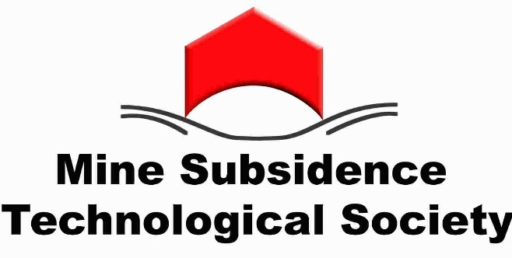
Figure 1 Mine Subsidence Technological Society Logo
The figures should be clear and neatly drawn, but do not need to be professionally drafted. Each should have a short caption indicating the figure number and content of the figure
The final text will be printed in colour. However, colour printing adds significantly to printing costs so it is preferred to keep the proportion of colour pages to less than a third of the total number of pages.
Tables should be legible and titled above with the table number and caption. Feel free to use whatever border style and formatting within the table gives the best clarity.
  - References
References should include in order, the authors surname, initials separated by “&” if there are more than one, the year of the publication, the reference title, the publication name, publishers and page numbers.
Full names of publications are preferred rather than abbreviations.
An example of the format for references is included at the end of this document. The first authors name should be hanging by 0.4 cm. Putting authors in alphabetical order makes is easier for readers.
- Your final product
Your final paper should be submitted as a pdf and Microsoft Word document file (*.doc or *.docx), containing all relevant figures and tables. This will allow us to compile all the papers into a single document with consistent headers and footers.

.

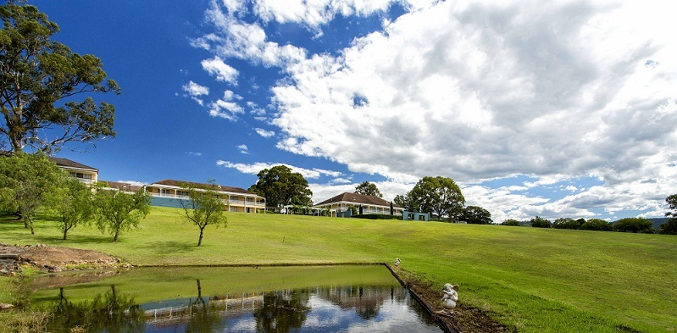
Figure 2 Full width figures between continuous section breaks. Width to match page width 16.2cm, preferably at top or bottom of page.

- Final submission date
Please note that the final submission date is the 1st September 2017. We would greatly appreciate your efforts to make this deadline. Please feel free to submit your papers earlier if you would like.
We ask for papers in electronic form, sent by email to papers@msts.org.au
If you foresee difficulties achieving these requirements or have any comments that would help to make this document clearer, please don’t hesitate to contact us via the website www.msts.org.au or by email to convenor@msts.org.au

- Acknowledgement
Thank you most kindly for agreeing to present a paper. Your work is of interest to the mine subsidence community and we are very keen for you to have the opportunity to present it at this conference.
- Example references
Jones T. 2010 “Guidelines for preparation of final papers” personal communication.
Holla L. 1991 “The experience of mining under public utilities in New South Wales” Proceedings of Mine Subsidence Technological Society Second Triennial Conference on Buildings and Structures Subject to Mine Subsidence, Maitland ISBN 0 646 05155 5, pp 57-65.

Footnotes should not encroach into the footer reserved for the proceedings.

